Database Fundamentals – Personalized Assignment

PART A & B: Design and Insert Data

CREATE DATABASE academic_system;
USE academic_system;

CREATE TABLE Students (
student_id INT PRIMARY KEY,
name VARCHAR(100) NOT NULL,
email VARCHAR(100) UNIQUE NOT NULL,
program VARCHAR(100) NOT NULL
);

INSERT INTO Students VALUES
(1,'Edwin Davis','edwin.davis@gmail.com','BSc Data Science'),
(2,'Anjali Nair','anjali.nair@gmail.com','BSc Data Science'),
(3,'Rahul Menon','rahul.menon@gmail.com','BSc Data Science'),
(4,'Sneha Thomas','sneha.thomas@gmail.com','BSc Data Science'),
(5,'Arjun Pillai','arjun.pillai@gmail.com','BSc Data Science');

CREATE TABLE Instructors (
instructor_id INT PRIMARY KEY,
name VARCHAR(100) NOT NULL,
department VARCHAR(100) NOT NULL
);

INSERT INTO Instructors VALUES
(1,'Dr. Mathew Varghese','Computer Science'),
(2,'Prof. Lakshmi Iyer','Statistics'),
(3,'Dr. Arun Krishnan','Artificial Intelligence');

CREATE TABLE Courses (
course_id INT PRIMARY KEY,
title VARCHAR(100) NOT NULL,
credits INT NOT NULL CHECK (credits > 0),
instructor_id INT,
FOREIGN KEY (instructor_id) REFERENCES Instructors(instructor_id)
);

INSERT INTO Courses VALUES
(101,'Database Management Systems',4,1),
(102,'Machine Learning',3,3),
(103,'Statistics for Data Science',3,2),
(104,'Python Programming',4,1);

CREATE TABLE Enrollments (
enrollment_id INT PRIMARY KEY,
student_id INT,
course_id INT,
semester ENUM('Spring','Summer','Fall') NOT NULL,
FOREIGN KEY (student_id) REFERENCES Students(student_id),
FOREIGN KEY (course_id) REFERENCES Courses(course_id)
);

INSERT INTO Enrollments VALUES
(1,1,101,'Spring'),
(2,1,102,'Spring'),
(3,2,101,'Spring'),
(4,3,103,'Summer'),
(5,4,104,'Fall'),
(6,5,101,'Spring'),
(7,2,102,'Spring'),
(8,3,104,'Fall');

CREATE TABLE Assessments (
assessment_id INT PRIMARY KEY,
course_id INT,
type VARCHAR(50),
max_marks INT NOT NULL,
FOREIGN KEY (course_id) REFERENCES Courses(course_id)
);

INSERT INTO Assessments VALUES
(1,101,'Assignment',50),
(2,101,'Exam',100),
(3,102,'Assignment',40),
(4,102,'Exam',100),
(5,103,'Exam',100),
(6,104,'Assignment',50);

CREATE TABLE Grades (
grade_id INT PRIMARY KEY,
enrollment_id INT,
assessment_id INT,
marks_obtained INT NOT NULL CHECK (marks_obtained >= 0 AND marks_obtained <= 100),
FOREIGN KEY (enrollment_id) REFERENCES Enrollments(enrollment_id),
FOREIGN KEY (assessment_id) REFERENCES Assessments(assessment_id)
);

INSERT INTO Grades VALUES
(1,1,1,45),
(2,1,2,80),
(3,3,1,40),
(4,6,2,75),
(5,2,3,35),
(6,7,4,85),
(7,4,5,70),
(8,5,6,48),
(9,8,6,42),
(10,2,4,90);

EXPLANATION: above written the ddl and dml commands
Defining student_id as primary key, and made email unique as every students will have unique email ids, marks_obtained is int because marks are whole numbers and helps for easy comparison with max_marks, added a check condition for marks obtained >=0 and <=100

Part C: SQL Queries

- Display all students enrolled in a given course (use JOIN).

SELECT s.name, c.title
FROM Students s
JOIN Enrollments e ON s.student_id = e.student_id
JOIN Courses c ON e.course_id = c.course_id
WHERE c.title = 'Database Management Systems';

//output:
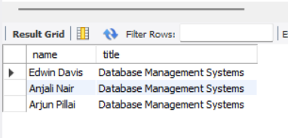

- Find the average marks for each course.

SELECT c.title, AVG(g.marks_obtained) AS average_marks
FROM Courses c
JOIN Assessments a ON c.course_id = a.course_id
JOIN Grades g ON a.assessment_id = g.assessment_id
GROUP BY c.title;
//Output:
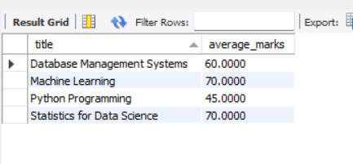

- List students who scored above the overall average

SELECT s.name, SUM(g.marks_obtained) AS total_marks
FROM Students s
JOIN Enrollments e ON s.student_id = e.student_id
JOIN Grades g ON e.enrollment_id = g.enrollment_id
GROUP BY s.name
HAVING total_marks > (SELECT AVG(marks_obtained) FROM Grades);

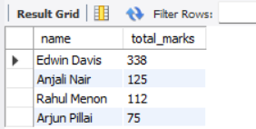

- Show the top 3 highest scoring students in a specific course

SELECT s.name, SUM(g.marks_obtained) AS total
FROM Students s
JOIN Enrollments e ON s.student_id = e.student_id
JOIN Grades g ON e.enrollment_id = g.enrollment_id
JOIN Courses c ON e.course_id = c.course_id
WHERE c.title = 'Python Programming'
GROUP BY s.name
ORDER BY total DESC
LIMIT 3;

//Output: (Only 2 such ppl are there)
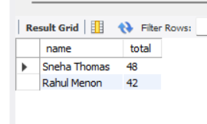
- Count how many students each instructor is teaching.

SELECT i.name, COUNT(e.student_id) AS total_students
FROM Instructors i
JOIN Courses c ON i.instructor_id = c.instructor_id
JOIN Enrollments e ON c.course_id = e.course_id
GROUP BY i.name;
//Output:
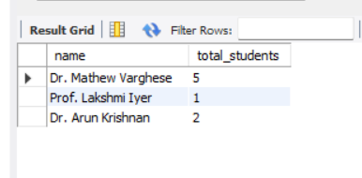

- Display courses that currently have no enrollments (use LEFT JOIN).

SELECT c.title
FROM Courses c
LEFT JOIN Enrollments e ON c.course_id = e.course_id
WHERE e.enrollment_id IS NULL;

//Output:
There are no such courses exists

Part D: Transactions and Data Integrity

- Write a transaction to enroll a student into a course and insert an initial grade record

START TRANSACTION;
INSERT INTO Enrollments VALUES (9,1,103,'Spring');
INSERT INTO Grades VALUES (11,9,5,88);
COMMIT;

- Demonstrate a ROLLBACK when an invalid grade (e.g., 150 marks) is attempted.
START TRANSACTION;
INSERT INTO Grades VALUES (12,1,2,150);
ROLLBACK;

//transaction will stop because 150 > 100 neglects our condition.

Explain why transactions are important in real systems such as banking, educationplatforms, or e-commerce?

“Transactions ensure that multiple related operations either complete fully or not at all. In banking, this prevents money from being deducted without being credited. In education systems, it ensures enrollment and grade records remain consistent. Without transactions, systems may produce incomplete or corrupted data”

Part E: Short Concept Questions

- DELETE vs TRUNCATE
DELETE removes specific rows and can be rolled back. TRUNCATE removes all rows instantly and resets auto-increment but cannot be rolled back in most cases.

- Foreign Keys
Foreign keys maintain relationships between tables. For example, a grade cannot exist without a valid enrollment. This prevents orphan records.

- Normalization
Normalization reduces redundancy and improves consistency. For example, instructor data is stored once in the Instructors table instead of repeating it in every course record.

THANKYOU
Edwin Davis

